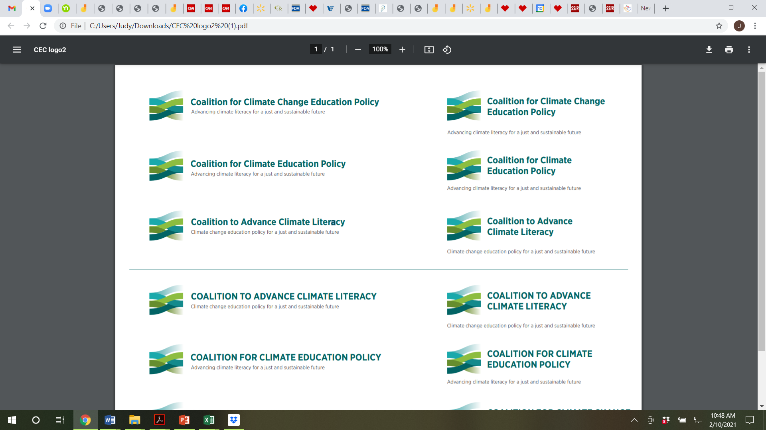

Draft letter to Michael S Regan, Administrator Designee of the U.S. Environmental Protection Agency. Organizational sign on letter.

Dear Administrator Regan,

Congratulations on your designation as Administrator of the U.S. Environmental Protection Agency. We, the undersigned organizations, wish you great success and stand ready to support you and your goals in the coming years.

We are specifically writing in support of the Agency’s longstanding environmental education (EE) program and your Office of Environmental Education. As you know, the Office was established via the passage of the National Environmental Education Act of 1990. The Act is multi-faceted and intentionally established a semi-autonomous office of EE at EPA, to make EE grants, youth awards, fellowships and professional development programs for educators and trainers. It also chartered the National Environmental Education Foundation as an official non-profit organization working in partnership with EPA, on creative agency and private sector initiatives.

Over the course of the past 30 years, the EPA’s EE program has made thousands of grants, large and small, to schools, nature centers museums, educational non-profits, and others. Every state and territory, many tribal agencies and nearly every county have benefited. Moreover, thousands of young people across America have been honored through the Presidential Environmental Youth Awards program. Importantly hundreds of thousands of educators have received professional development and training support as a result of the EPA’s EE program.

The National Environmental Education Foundation, which is partially funded through the Act, leverages the funds it receives on an average of three to one to conduct a number of critical national programs covering education around environmental health, natural resources, air and water quality and more. Signature Foundation programs include National Environmental Education Week and National Public Lands Day which is one the largest single volunteer work days in America generating millions of dollars in contributed work. Since 1990, the Foundation has leveraged some $250 million in financial and in-kind support for environmental education and public lands and community programs.

Our main reasons for writing to you are to respectfully request the following:

* First, that you include funding for the EPA EE program in the Agency’s official budget request to the White House as part of the Administration’s annual budget submission to Congress.
* Second, that you request full funding at $14 million as authorized by the National Environmental Education Act of 1990.
* Third, that you and your executive team view the Office of Environmental Education as having useful expertise in the discipline of truly rigorous environmental education and training,
* Fourth, that, through the EPA EE program, you pursue climate and environmental education and training that supports social and environmental equity and justice across the nation.
* Fifth, that you encourage cooperation and partnerships between the Office of EE and other EPA Offices and their Assistant Administrators and the regional offices to improve the internal synergies for education and training as viable tools for environmental improvement, and
* Sixth, that you ramp up the focus of the program on preparing young people and the future workforce for the challenges and opportunities inherent in climate change.

Each year, the organizations represented by this letter work on Capitol Hill to insure there is actual funding for the EPA EE program. It is very helpful to have the support of the Administrator in these efforts and it will be critical to also have your support of a nationwide goal of climate literacy and related job and career development. The EPA EE program plays an important national role in supporting education and training and we look forward to working with you to support nationwide climate and environmental literacy of students, educators, government and business leaders, entrepreneurs, professionals and others.

A delegation from the undersigned organizations would welcome the opportunity to meet with you, via a virtual meeting, to discuss these requests.

Again, best wishes for a successful term as EPA Administrator and we look forward to working with you and talking to you soon.

Sincerely,

Organizations

Attachment: Letter to the U.S. Senate Leadership supporting the confirmation of Michael S. Regan for EPA Administrator.