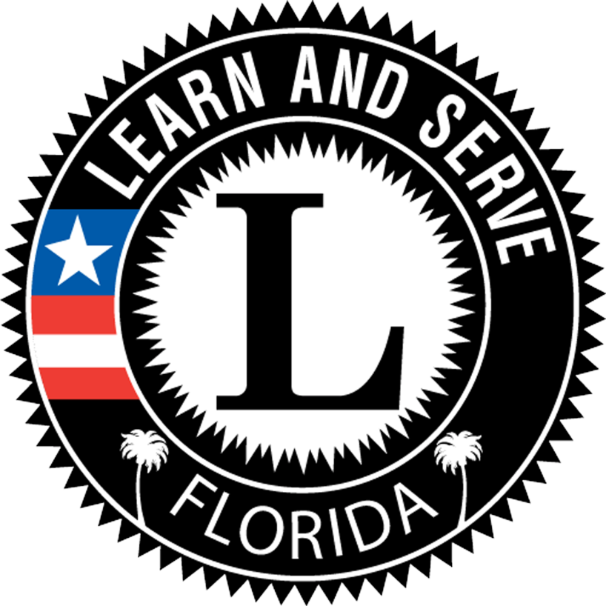Rubric for Gauging Progress on Meeting National Service-Learning Standards
 | - Novice | - Introductory | - Experienced | - Advanced
Duration and Intensity  Service-learning has sufficient duration and intensity to address community needs and meet specified outcomes. | Project is brief (less than two weeks) and addresses an immediate need without providing a long-term solution. Processes of investigation, planning, action, reflection, and demonstration/ celebration of impacts are weak. Minimal amount of time and intensity are provided/included. | The S-L experience is carried out over a short time period (a few weeks), addresses an immediate need and provides only a start to a long-term solution. The processes of investigating community needs, planning, action, reflection, and demonstration/celebration drive the project somewhat, resulting in limited time and intensity. | The process of investigating community needs, planning, action, reflection, and demonstration/ celebration is used on a limited basis. Service-Learning is conducted over a significant period of time. The project addresses community need but falls short of achieving all learning outcomes. | The process of investigating community needs, planning, action, reflection, and demonstration/celebration of learning and impacts on self and community is used consistently. Service-learning is conducted during concentrated blocks of time across a period of weeks or months, providing time to address identified community needs and achieve learning outcomes.
Link to Curriculum  Service-learning is intentionally used as an instructional strategy to meet learning goals and/or content standards. | Project uses skills that can be found in the standards, but they aren’t the foundation out of which the project grows. Skills incorporated into the experience are at lower levels on the hierarchy of learning. Service is not intentionally connected to learning and is seen as mainly an add-on or enrichment activity. | Students master basic skills through the S-L project, but the link to curriculum is weak and not intentional. Experience does not align with content standards and is not used to push learning to higher levels of application. Student is recognized on school records, but no formal school or district policy is in place identifying or promoting it to enhance learning. | Project work leads students toward mastery of more complex skills in a rigorous and relevant curriculum. Instruction assists students in completion of project, though the link may not be direct and intentional. Service-learning is an integral part of the academic expectations for students throughout the school or district. | Participants learn how to transfer knowledge and skills from one setting to another. Service-learning is explicitly aligned with academic curricula; learning goals are clearly articulated. Students construct knowledge through challenging tasks in a rigorous and relevant curriculum. Service-learning is formally recognized in school board policies and student records.
Partnerships  Service-learning partnerships are collaborative, mutually beneficial, and address community needs. | Project is determined and implemented with little involvement from community partners or is grounded in meeting a need for service presented by the community partner or school. A shared vision and collaborative partnership has not been established or maintained. | Partnerships are few or limited. Limited interactions with community partners lead to meeting a minimal community need. Project reflects a partial shared vision with minimal collaborative work between the partners. Service is not designed to be reciprocal or of mutual benefit to both servers and served. | Some communication and ongoing interaction with community partners is central to the project. Students work with partners to develop common goals. More opportunities could be provided to encourage students to see community members as collaborative partners and resources, and not just recipients of service. | A variety of partners are engaged. Partnerships engage in frequent and regular communication, establish a shared vision and set common goals, and collaboratively develop and implement action plans to meet specified goals. Partners share knowledge and understanding of school and community assets and needs, and view each other as valued resources.
Meaningful Service  Service-learning actively engages participants in meaningful and personally relevant service activities. | Students provide indirect service with no contact with population being served. Project is determined without a community needs assessment and does not lead to attainable and visible outcomes. Experience is not appropriate for students’ age and developmental level and/or issue is not personally relevant. Students have little or no significant roles in service design. | Community needs assessment is done in isolation from the community. Project includes some contact with those being served. Outcomes are attainable and visible, but do little to contribute toward lasting change. Students do not understand their service experiences in the context of the underlying societal issues being addressed. Students have some voice and roles in service design. | Project addresses a real need connected to a personally relevant issue and provides direct contact with those being served. Outcomes are attainable and visible, but may not be highly valued by those being served in the school, local, and/or global community. Students have meaningful roles in project selection, design, and implementation. | Experiences are developmentally appropriate, address personally relevant issues, and encourage participants to understand their service experiences in the context of the underlying societal issues being addressed. Interesting and engaging service activities lead to attainable and visible outcomes that have significant impact on participants and others. Students have leadership roles in project selection, design, and implementation.
Based on the K-12 Service-Learning Standards for Quality Practice. National Youth Leadership Council, 2008. Modification of draft rubric created by the Wisconsin Department of Public Instruction, 2009.
Rubric for Gauging Progress on Meeting National Service-Learning Standards, cont.
 | - Novice | - Introductory | - Experienced | - Advanced
Youth Voice  Service-learning provides youth with a strong voice in planning, implementing, and evaluating service-learning experiences with guidance from adults. | Teacher determines project with very limited or no student input. Task completion is determined and monitored by the teacher. Teacher evaluates quality and effectiveness of the service-learning experience without student input. | Teacher determines project and offers strong guidance in organizing and completing project tasks. Students are allowed to provide input into decisions, but final determination is made by the teacher. Youth have limited opportunities to demonstrate their abilities and decision-making skills. | Teacher works with students in determining project based on standards. All students work collaboratively to develop project plan and take leadership in carrying out tasks. Teacher helps to shape decisions throughout the process, but places primary emphasis on student voice. | Youth are engaged in generating ideas, identifying learning outcomes, and decision-making during planning, implementation, and evaluation. Youth acquire knowledge and skills to enhance leadership and decision-making and are involved in evaluating the quality and effectiveness of the S-L experience. Youth and adults are involved in creating an environment that supports trust and open expression of ideas.
Diversity  Service-learning promotes understanding of diversity and mutual respect among all participants. | Students’ pre-conceptions and stereotypes are not challenged. Multiple perspectives are not intentionally sought or incorporated into service-learning experience. Decisions are made by vote rather than consensus. Project lacks diversity of participants, partners, and activities. | Understanding of multiple perspectives is limited to tolerance and acceptance of others. Students’ pre-conceptions are challenged on a limited basis but project could further address engaging the perspective of recipients of service (people and/or places). Project has limited diversity of participants, partners, and activities. | Some time is spent identifying and overcoming stereotypes and valuing different points of view. Students’ pre-conceptions and stereotypes are somewhat challenged. Some collaboration incorporating multiple perspectives is developed. Service activities provide direct opportunities for diverse interactions, experiences | Project has participants analyze different points of view to gain understanding of multiple perspectives, develop interpersonal skills in conflict resolution and decision-making, recognize and overcome stereotypes, and understand and value the diverse backgrounds and perspectives of those offering and receiving service. Decisions are made through a consensus process.
Reflection  Service-learning incorporates multiple challenging reflection activities that are ongoing and that prompt deep thinking and analysis about oneself and one’s relationship to society. | Basic reflection is provided for at the end of the S-L experience using 1 or 2 methods (e.g., journal, discussion). Reflection does not demonstrate complex analysis of broader social and civic issues. Examination of preconceptions and assumptions is not incorporated into reflection. | Reflection consists of documenting progress of project and has no clear connection to skills being developed. Project could do more to deepen the level of reflection for students and challenge them to identify, research, and discuss alternative solutions. | Meaningful reflection is planned and integral to the project and is used to teach and/or reinforce core academic skills and/or content. Reflection includes some emphasis on higher order thinking skills. Students are prepared for service-related tasks in connection with skill instruction. Project challenges students to identify, research, and implement alternative solutions. | Participants think deeply about complex community problems and alternative solutions and examine a variety of social and civic issues. Participants examine preconceptions in understanding their responsibilities and roles as citizens. It occurs before, during, and after the experience and includes a variety of verbal, written, artistic, and nonverbal activities to demonstrate changes in participants’ knowledge, skills, and/or attitudes.
Progress Monitoring  S-L engages participants in an ongoing process to assess the quality of implementation and progress toward meeting specified goals, and uses results for improvement and sustainability. | Teacher and students follow implementation plans without collecting data to guide decisions or measure impacts on servers or served. No clear connection exists to specific goals and learning outcomes. | Teacher assesses outcome of learning activities separate from service-learning experience. Teacher and students gather evidence of progress, but do not base decisions on data collected in a formative or a summative way. | Evidence collected provides a picture of student progress throughout the service-learning experience and guides both instruction and project implementation. Students are involved in measuring impacts of their efforts. | Evidence of quality S-L implementation and progress toward meeting specific goals and learning outcomes is collected from multiple sources. Evidence is used to improve experiences and progress toward goals. Evidence is communicated to broader communities to deepen understanding of S-L and ensure high quality practices. Students have significant roles in measuring impacts, on themselves and others.
Self-Assessment Scores: Duration____ + Curriculum____ + Partnerships____ + Service____ + Youth Voice____ + Diversity____ +
Reflection____ + Monitoring____ =______ (out of 32). Interpretation: 8-12=Novice, 13-19=Introductory, 20-26=Experienced, 27-32=Advanced

