Missouri Green Schools

**Expansion Project Fact Sheet**

Details current as of Oct. 1, 2019

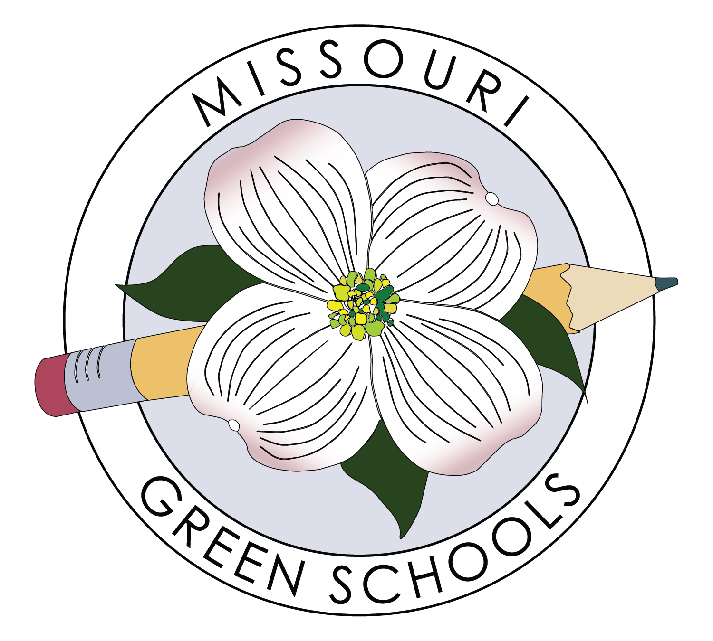

# OVERVIEW

With funding and other, varied support from the Missouri Foundation for Health (MFH), and collaboration with key partners USGBC-Missouri Gateway Chapter (USGBC-MGC) and Missouri River Communities Network (MRCN), the Missouri Environmental Education Association (MEEA) will engage in a 3-year project to:

1) expand our capacity to enroll more Missouri schools in the Missouri Green Schools (MGS) program and provide state-level recognition to MGS schools, and

2) engage high needs Missouri schools in MGS by providing extra support following the MFH Healthy Schools Healthy Communities (HSHC) model, which we are designating MGS+. Launch of MGS+ services anticipated Fall 2020.

# HOW DOES MISSOURI GREEN SCHOOLS WORK?

* Schools establish a Green Team
* Schools enroll in MGS and conduct a self-assessment for each pillar of a green school: environmental impact, health and wellness, sustainability education
* Schools use the MGS assessment tool to generate ideas for next steps and develop action plans; MGS+ enrollees receive extra support to set and achieve goals across all 3 pillars
* Schools receive recognition for reaching Emerging, Progressing, and Advanced Levels of MGS
* Advanced Level schools are eligible for the US Department of Education Green Ribbon School Award

# missourigreenschools.org

# MFH SERVICE AREA & ‘HEALTHY SCHOOLS HEALTHY COMMUNITIES’ MODEL OF SUPPORT

* MGS+ approach based on HSHC model:
  + Site visits to schools to provide training in baseline assessments, action planning, data collection, and progress tracking
  + Monthly phone calls with Green Teams, which include school staff from multiple departments, parents, community partners for site-specific projects, and MGS partners
  + Assistance with action planning and troubleshooting via phone and email as needed
  + Incorporate feedback mechanisms into relationships with MGS+ schools (surveys, interviews) that provide insight into factors that lead to high-impact, long-lived changes
  + Funding support for professional development opportunities and a small grants program for buildings and grounds improvements or other capacity-building needs as determined by the school
  + Following the HSHC model, schools with 60% or higher rate of Free and Reduced Lunch Plan eligibility will be given priority to enroll in MGS+. If our organizational capacity allows, the threshold could be reduced to 40%.
* MFH Service area excludes the KC and Northwest regions of MEEA’s membership regions. Schools in these 2 regions may enroll in MGS, but we do not have the capacity to provide MGS+ services at this time. By the end of the 3-year project with MFH, or sooner if we raise funds for that, we should have the capacity to start providing extra support for these regions.

# STAFF SUPPORT

* Bring in AmeriCorps VISTAs by the end of Year 1 to build the capacity of MGS generally and to provide some of the 1:1 consultations to MGS+ schools
* MEEA, USGBC-MGC, and MRCN will dedicate staff time to promoting MGS/MGS+ to school system leaders and providing training and 1:1 support to MGS+ schools and VISTAs
* MEEA and USGBC-MGC will continue to work closely with the MGS Committee to roll out a state-level MGS recognition program and to incorporate an online assessment and tracking tool for use by all MGS schools
* MEEA, USGBC, and MRCN will work collectively to develop and promote MGS Partnership Network. First steps toward this will take place at MELAB on Dec. 12, 2019.
* MEEA and partners will create a Fund Development Plan for the small grants program for MGS+ schools; MFH has seeded this fund with $42,000.
* Other MFH support includes media coaching, partnership development, convening space, troubleshooting, and grant-writing assistance. So many wonderful resources via this amazing organization!

